Flow Sensor-Adruino Setup
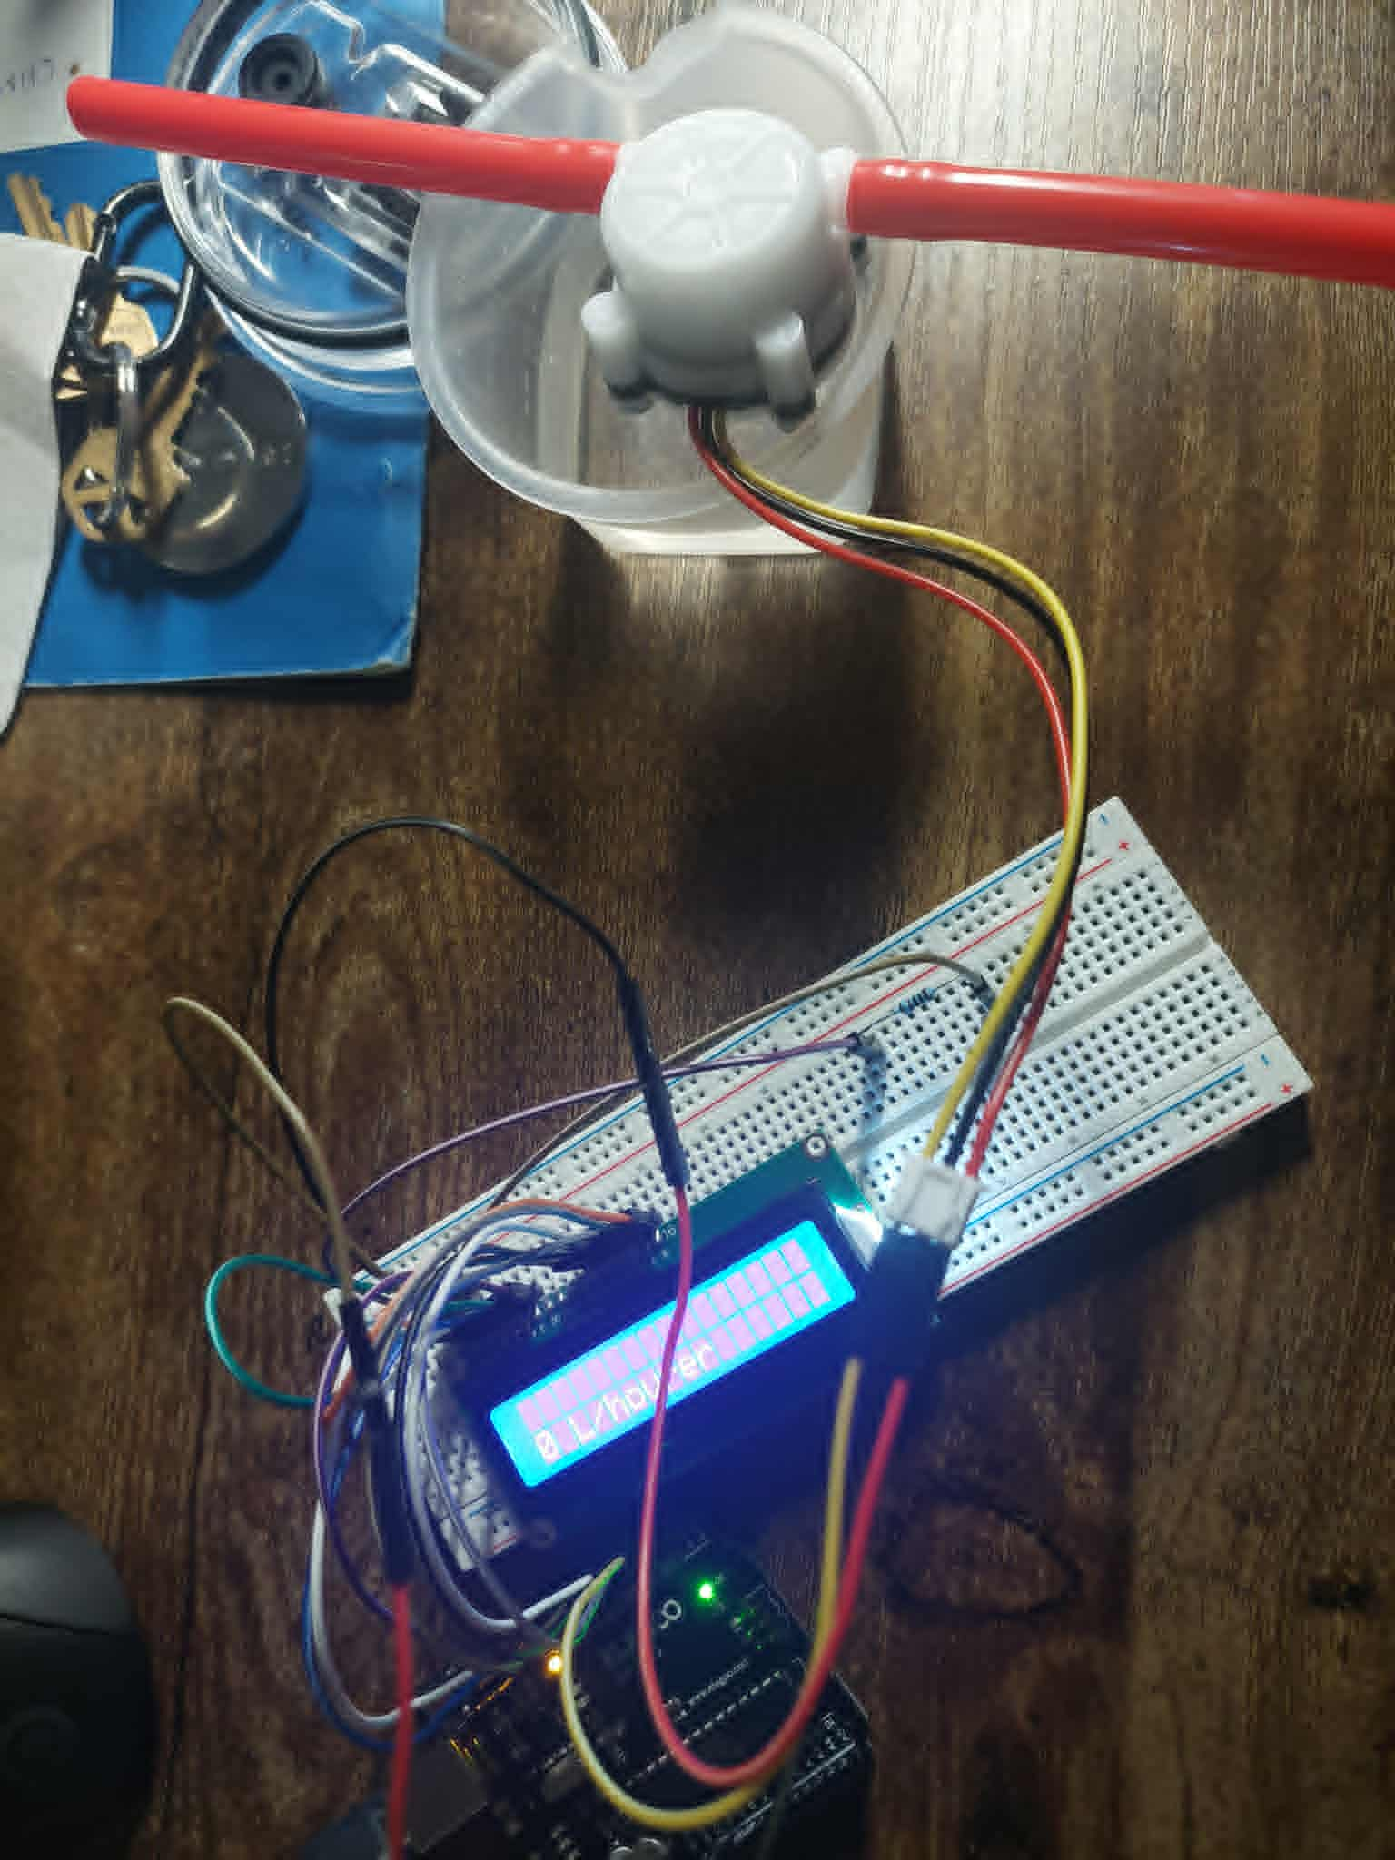

Code to measure the flow rate/hour-Adruino UNO-R3
/*
This tutorial Demonstrates the use of Flow Sensor
The circuit:
Flow Sensor Connections
Yellow --- Pin 6
Red --- +5V
Black --- GND

LCD Connections
* LCD RS pin to digital pin 12
* LCD Enable pin to digital pin 11
* LCD D4 pin to digital pin 6
* LCD D5 pin to digital pin 5
* LCD D6 pin to digital pin 4
* LCD D7 pin to digital pin 3
* LCD R/W pin to ground
* 1K resistor:
* One end to ground
* Another end to LCD VO pin (pin 3)

This example code is in the public domain.
*/

// include the library code:
#include <LiquidCrystal.h>

// initialize the library with the numbers of the interface pins
LiquidCrystal lcd(12, 11, 6, 5, 4, 3);

volatile int FlowPulse; //measuring the rising edges of the signal
int Calc;
int flowsensor = 2; //The pin location of the sensor

void setup() {

pinMode(flowsensor, INPUT); //initializes digital pin 2 as an input
Serial.begin(9600); //This is the setup function where the serial port is initialised,
attachInterrupt(0, rpm, RISING); //and the interrupt is attached

// set up the LCD's number of columns and rows:
lcd.begin(16, 2);
// Print a message to the LCD.
lcd.setCursor(0, 1);
lcd.print("Flow Meter");
}

void loop() {

FlowPulse = 0; //Set NbTops to 0 ready for calculations
sei(); //Enables interrupts
delay (1000); //Wait 1 second
cli(); //Disable interrupts
Calc = (FlowPulse * 60 / 7.5); //(Pulse frequency x 60) / 7.5Q, = flow rate in L/hour
Serial.print (Calc, DEC); //Prints the number calculated above
Serial.print (" L/hour\r\n"); //Prints "L/hour" and returns a new line

// set the cursor to column 0, line 1
// (note: line 1 is the second row, since counting begins with 0):
lcd.setCursor(0, 2);
lcd.print(Calc,DEC); // print the Flow Rate
lcd.print(" L/hour");
}

void rpm () //This is the function that the interupt calls
{
FlowPulse++; //This function measures the rising and falling edge of the hall effect sensors signal
}

From the code and from the testing that I can measure the flow rate/hour when I drink the water.
The video that show my testing:

https://drive.google.com/file/d/1jCwSyMHyAUF-OZ0aAI6PoX8ZYKnSa8AN/view?usp=sharing

Water Pressure Sensor and Flow Sensor Implementation:
Setup:
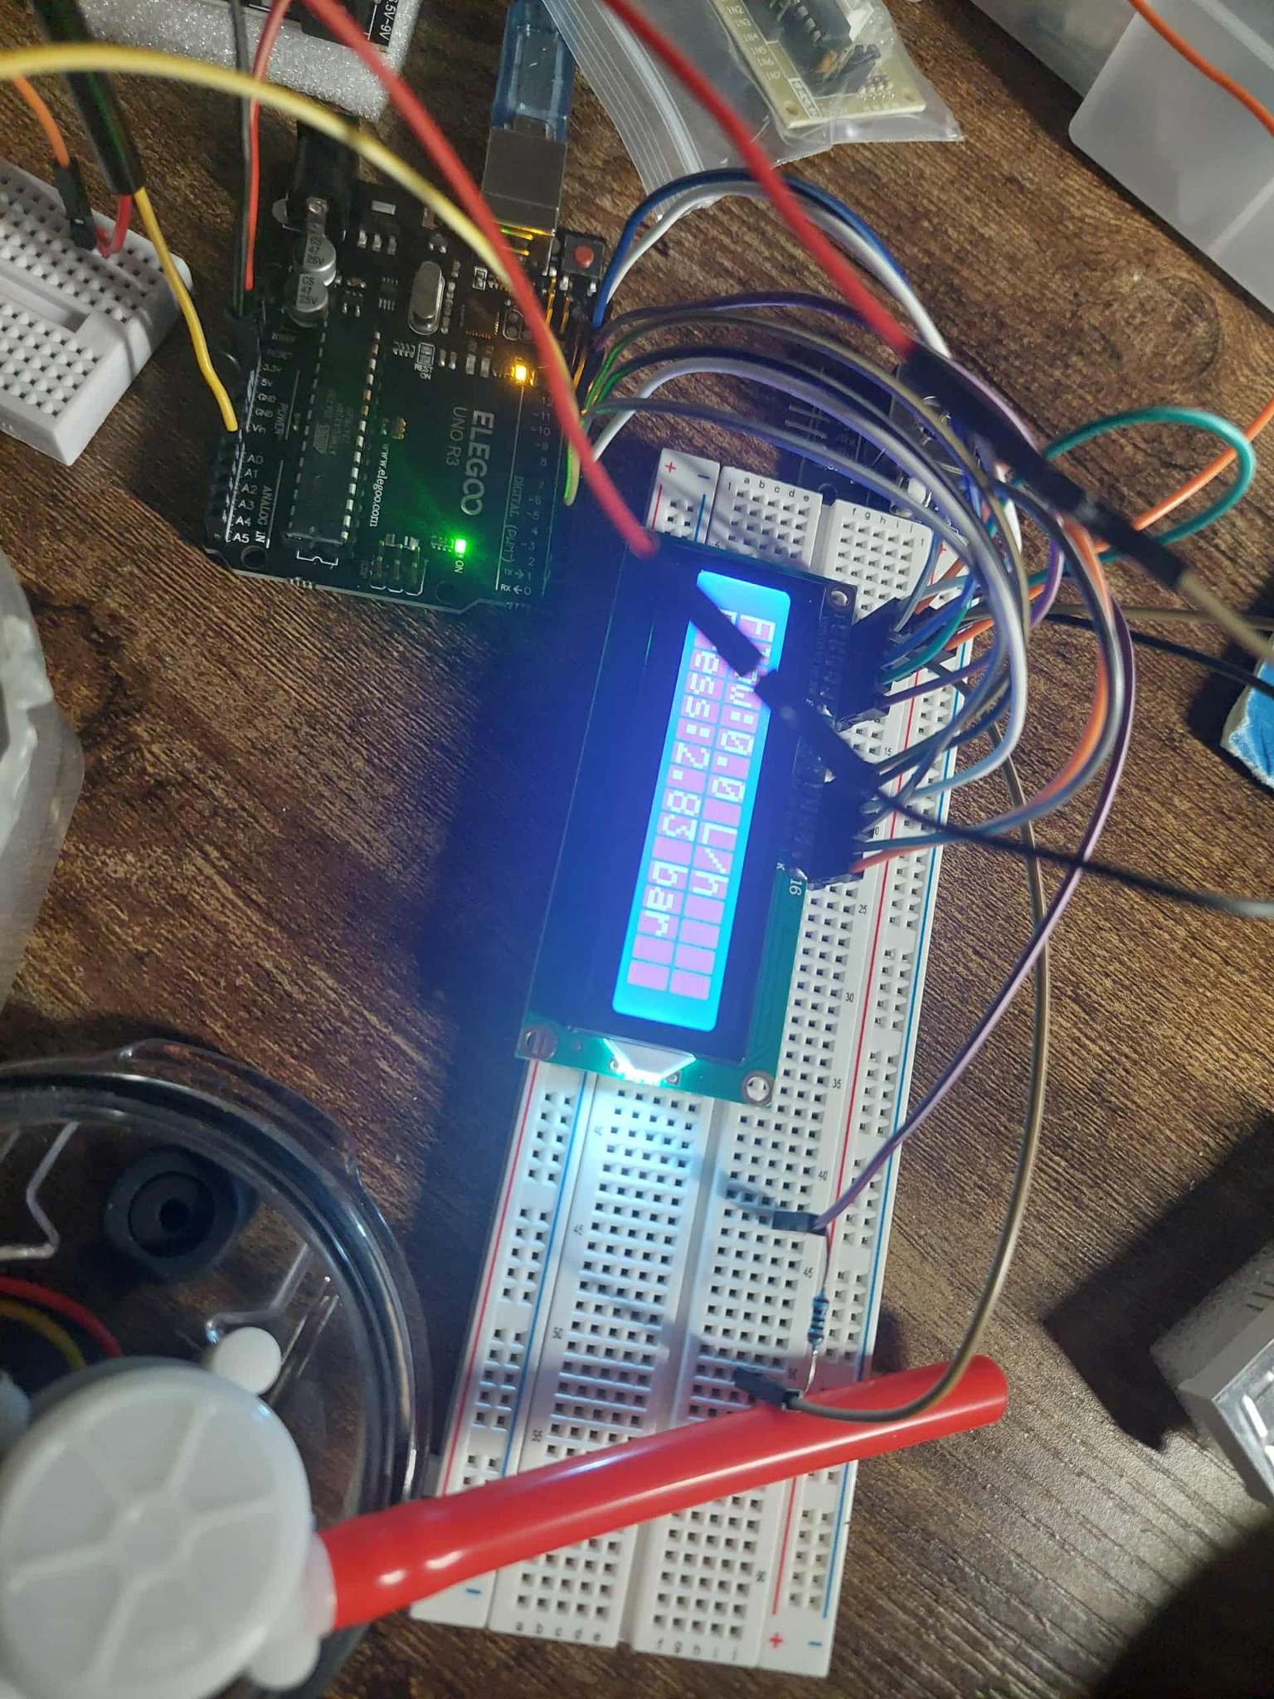

#include <LiquidCrystal.h>

// ===== LCD Setup =====
// RS, EN, D4, D5, D6, D7
LiquidCrystal lcd(12, 11, 6, 5, 4, 3);

// ===== Flow Sensor Variables =====
volatile int FlowPulse = 0;
const int flowSensorPin = 2; // Signal pin (must be interrupt-capable)
float flowRate = 0; // Flow rate in L/h

// ===== Pressure Sensor Variables =====
const int pressurePin = A0; // Analog pin for pressure sensor
float voltage = 0;
float pressureBar = 0;

// ===== Pressure Sensor Calibration (adjust for your sensor) =====
// Example: 0.5V = 0 bar, 4.5V = 10 bar range
const float SENSOR_MIN_V = 0.5;
const float SENSOR_MAX_V = 4.5;
const float SENSOR_MAX_BAR = 10.0;

void setup() {
// --- Flow Sensor Setup ---
pinMode(flowSensorPin, INPUT);
attachInterrupt(digitalPinToInterrupt(flowSensorPin), countFlowPulse, RISING);

// --- LCD Setup ---
lcd.begin(16, 2);
lcd.clear();
lcd.print("Flow & Pressure");
delay(1500);
lcd.clear();
}

void loop() {
// ===== FLOW MEASUREMENT =====
FlowPulse = 0;
sei(); // Enable interrupts
delay(1000); // 1 second sampling window
cli(); // Disable interrupts while calculating

flowRate = (FlowPulse * 60.0) / 7.5; // (pulses/sec * 60) / 7.5 = L/hour

// ===== PRESSURE MEASUREMENT =====
long sum = 0;
for (int i = 0; i < 256; i++) {
sum += analogRead(pressurePin);
}

float avgReading = sum / 256.0;
voltage = (avgReading / 1023.0) * 5.0;

// Convert voltage to pressure (bar)
if (voltage < SENSOR_MIN_V) voltage = SENSOR_MIN_V;
if (voltage > SENSOR_MAX_V) voltage = SENSOR_MAX_V;
pressureBar = (voltage - SENSOR_MIN_V) * (SENSOR_MAX_BAR / (SENSOR_MAX_V - SENSOR_MIN_V));

// ===== DISPLAY ON LCD =====
lcd.clear();
lcd.setCursor(0, 0);
lcd.print("Flow:");
lcd.print(flowRate, 1);
lcd.print(" L/h");

lcd.setCursor(0, 1);
lcd.print("Press:");
lcd.print(pressureBar, 2);
lcd.print(" bar");

delay(500); // update display every half-second
}

// ===== Interrupt Service Routine =====
void countFlowPulse() {
FlowPulse++;
}
Video for testing:
https://drive.google.com/file/d/1js5R-PyfKN3PnXYvObnWPi85uGRnpN6p/view?usp=sharing

